**1-way Independent ANOVA**

n = _____

K = _____

nT = _____

Setup: Started with 24 subjects, randomly divided them equally into three groups.

Each group was taught with a different method.

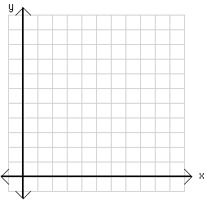

Means Plot

**dfTOTAL**

( nT – 1 )

**dfBet-group**

( k – 1 )

**dfWith-group**

( nT – k )

|  |  |  |
| --- | --- | --- |
| Traditional | Video | Computer |
| 72  83  96  79  83  95  89  98 | 69  66  78  64  96  87  93  86 | 63  72  78  59  89  93  86  95 |
| MTrad = 86.875  STrad = 9.1875 | MVid = 79.875  SVid = 12.4607 | MComp = 79.375  SComp = 13.6585 |

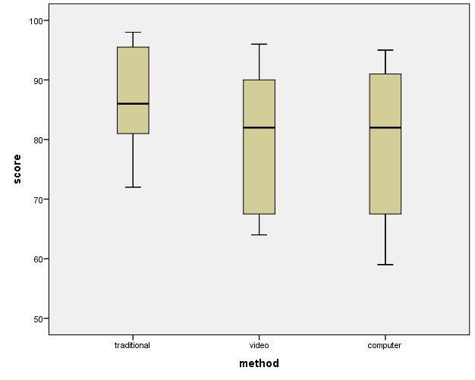

|  |  |  |  |  |  |
| --- | --- | --- | --- | --- | --- |
| Source | SS | df | MS | F | p |
| Between-Groups |  |  |  |  |  |
| Within-Groups (**Residual**) |  |  |  |  |  |
| Total |  |  |  | *Fcrit(___, ___) = ______* | |

**2-way Independent ANOVA**

n = _____

c = _____

r = _____

nT = _____

Setup: Started with 24 subjects; half are gifted .

Randomly divided each set of 12 them into three equal groups.

Each group was taught with a different method.

**dfTOTAL**

( nT – 1 )

**dfBet-Cell**

( rc – 1 )

**dfWith-Cell**

( nT – rc )

**dfRow**

( r – 1 )

**dfCol**

( c - 1 )

**dfRow x Col**

( r - 1)*( c - 1 )

|  |  |  |  |  |  |  |  |
| --- | --- | --- | --- | --- | --- | --- | --- |
|  | Traditional | | Video | | Computer | |  |
| Average | 72  83  96  79 | M = 82.5  S = 10.083 | 69  66  78  64 | M = 69.25  S = 6.1847 | 63  72  78  59 | M = 68  S = 8.6023 | MDep = 73.25 |
| Gifted | 83  95  89  98 | M = 91.25  S = 6.6521 | 96  87  93  86 | M = 90.5  S = 4.7958 | 89  93  86  95 | M = 90.75  S = 4.0311 | MNot = 90.8333 |
|  | MTrad = 86.875 | | MVid = 79.875 | | MComp = 79.375 | | MGrand = 82.0417 |



Means Plot

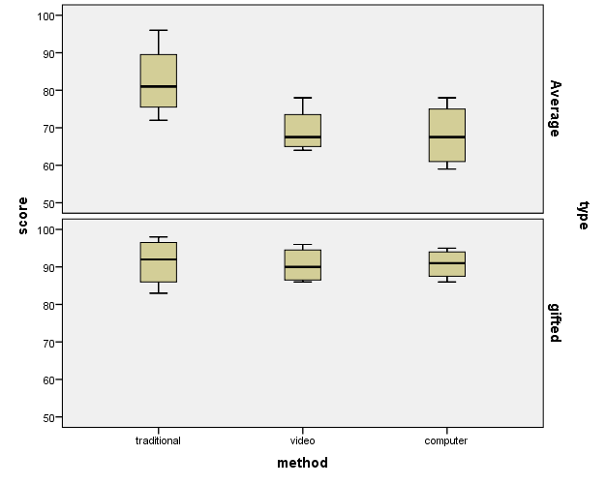

|  |  |  |  |  |  |
| --- | --- | --- | --- | --- | --- |
| Source | SS | Df | MS | F | p |
| Between-Cells |  |  |  |  |  |
| Row Groups |  |  |  |  |  |
| Column Groups |  |  |  |  |  |
| INTER (Row x Col) |  |  |  |  |  |
| Within-Cells (**Residual**) |  |  |  | *Fcrit(___, ___) = ______*  *Fcrit(___, ___) = ______* | |
| Total |  |  |  |

**SPSS: 1-way independent ANOVA (just method type)**

ONEWAY score BY method.

|  |  |  |  |  |  |
| --- | --- | --- | --- | --- | --- |
| **ANOVA** | | | | | |
| Score | | | | | |
|  | Sum of Squares | df | Mean Square | F | Sig. |
| Between Groups | 281.333 | 2 | 140.667 | .990 | .388 |
| Within Groups | 2983.625 | 21 | 142.077 |  |  |
| Total | 3264.958 | 23 |  |  |  |

UNIANOVA score BY method.

|  |  |  |  |  |  |
| --- | --- | --- | --- | --- | --- |
| **Tests of Between-Subjects Effects** | | | | | |
| Dependent Variable: score | | | | | |
| Source | Type III Sum of Squares | df | Mean Square | F | Sig. |
| Corrected Model | 281.333a | 2 | 140.667 | .990 | .388 |
| Intercept | 161540.042 | 1 | 161540.042 | 1136.986 | .000 |
| method | 281.333 | 2 | 140.667 | .990 | .388 |
| Error | 2983.625 | 21 | 142.077 |  |  |
| Total | 164805.000 | 24 |  |  |  |
| Corrected Total | 3264.958 | 23 |  |  |  |
| a. R Squared = .086 (Adjusted R Squared = -.001) | | | | | |

ONEWAY score BY method

/CONTRAST 1 -1 -1

/STATISTICS DESCRIPTIVES HOMOGENEITY

/PLOT MEANS

/MISSING ANALYSIS

/POSTHOC LSD BONFERRONI ALPHA(0.05).

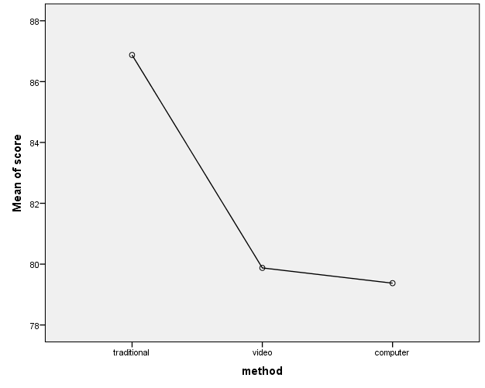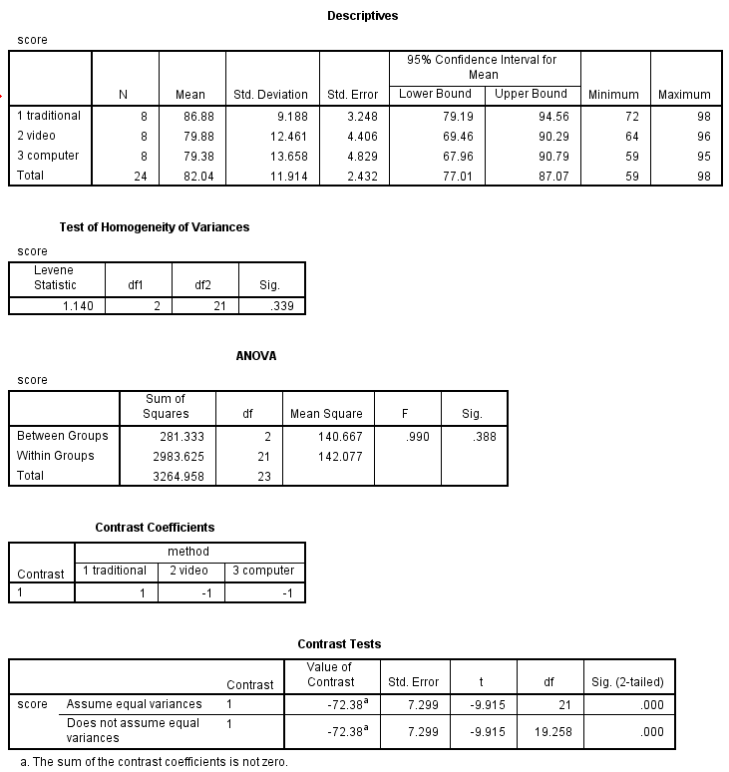

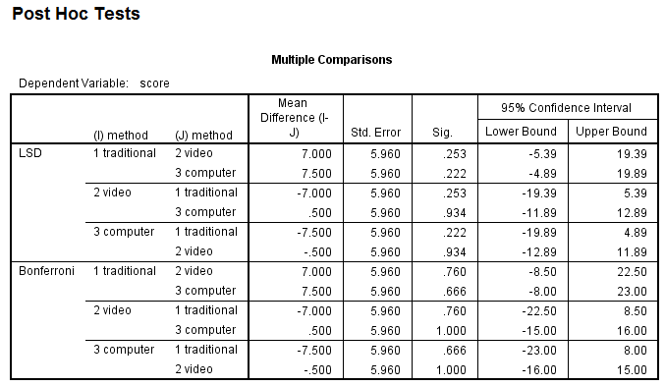

**SPSS: 2-way independent ANOVA (avg/gifted & mehtod type)**

UNIANOVA score BY type method.

|  |  |  |  |  |  |
| --- | --- | --- | --- | --- | --- |
| **Tests of Between-Subjects Effects** | | | | | |
| Dependent Variable: score | | | | | |
| Source | Type III Sum of Squares | df | Mean Square | F | Sig. |
| Corrected Model | 2372.708a | 5 | 474.542 | 9.573 | .000 |
| Intercept | 161540.042 | 1 | 161540.042 | 3258.863 | .000 |
| type | 1855.042 | 1 | 1855.042 | 37.423 | .000 |
| method | 281.333 | 2 | 140.667 | 2.838 | .085 |
| type * method | 236.333 | 2 | 118.167 | 2.384 | .121 |
| Error | 892.250 | 18 | 49.569 |  |  |
| Total | 164805.000 | 24 |  |  |  |
| Corrected Total | 3264.958 | 23 |  |  |  |
| a. R Squared = .727 (Adjusted R Squared = .651) | | | | | |

UNIANOVA score BY type method

/POSTHOC method(LSD)

/POSTHOC type

/PLOT PROFILE(method*type)

/EMMEANS TABLES(type) COMPARE

/EMMEANS TABLES(method) COMPARE

/EMMEANS TABLES(type*method) COMPARE (method)

/PRINT OPOWER ETASQ HOMOGENEITY DESCRIPTIVE

/CRITERIA=ALPHA(.05)

/DESIGN type method type*method.

